Revolutionizing Supply Chain and Logistics: The Power of Blockchain Monitoring

Chanda Chouhan

Archi Gehlot, Gautam Yadav, Jatin Ahuja

*Department of Information & Technology, Medi-Caps University, Indore-452010, India*

**Abstract:**

The study goes into the diverse world of blockchain-enabled supply chain management systems, presenting them as disruptive solutions that use the inherent benefits of decentralization, transparency, and smart contract automation. It methodically tackles current gaps in the literature using a mix of systematic reviews, case studies, and empirical research. Notably, the inclusion of a comprehensive framework for blockchain adoption in distribution networks offers a realistic perspective on the management and technological factors required for effective implementation. A sophisticated bibliometric study provides a 360-degree perspective of the worldwide landscape of blockchain research in logistics and supply chain management, casting light on trends, notable academics, and research hotspots, therefore providing significant insights to the academic community. Furthermore, we will explore the complex relationship between blockchain integration and supply chain operations across many sectors. The investigation encompasses opportunities, societal implications, cutting-edge technology, and current trends and difficulties. This section carefully categorizes the effects on economic, environmental, and social sustainability across several industrial sectors, providing a comprehensive grasp of blockchain's disruptive capability. The findings synthesis not only enriches our current understanding of blockchain applications in supply chain management, but it also propels the discussion forward by proposing a future research agenda, providing a comprehensive and forward-looking contribution for researchers, practitioners, and decision-makers alike.

Index Terms—Supply Chain Management, Blockchain, Dis-

tributed Ledgers, Consensus

Index Terms—Supply Chain Management, Blockchain, Dis-

tributed Ledgers, Consensus

Index Terms—Supply Chain Management, Blockchain, Dis-

tributed Ledgers, Consensus

index Terms—Supply Chain Management, Blockchain, Dis-

tributed Ledgers, Consensus

index Terms—Supply Chain Management, Blockchain, Dis-

tributed Ledgers, Consensus

index Terms—Supply Chain Management, Blockchain, Dis-

tributed Ledgers, Consensus

index Terms—Supply Chain Management, Blockchain, Dis-

tributed Ledgers, Consensus

**Index Terms**—Supply Chain Management, Blockchain, Logistics Monitoring, Distributed Ledgers.

**1. Introduction:**

The supply chain has a prominent role in product manufacturing and people’s lives, as people are dependent on it. Supply chain connects human beings and nature for the exchange of goods. Timely sharing and tracking of real-time product details across the supply chain ensure a smooth transportation process, facilitating the seamless movement of goods from producers to consumers. Recently, blockchain technology stands as a dependable solution in the realm of supply chain management. The integration of blockchain in this field can help record real time data at each node in every step. Data sharing and full traceability is achieved throughout the product lifecycle, which solves the problem of accountability in supply chain. The timely distribution of item data based on blockchain technology increases the satisfiability of customers, which overall improves the competitiveness. It can have applications in various scenarios.

For Instance, Blockchain technology decentralised systems can be applied in financial field, Healthcare sector, e commerce. In the past few years, blockchain has been applied to big data, IoT and AI.

Despite prolonged research, many difficulties in this field have not been resolved. These unanswered questions are mainly of the transportation process, supply and information management. These blockchain chain network guarantees the credibility of data at every step by broadcasting it in the public ledger, achieving consensus. This ensures decentralisation, transparency, verification and traceability. It is a need to monitor, adulting and ensuring compliance as it ensures traceable, tamper proof services.

Walmart and IBM have implemented some blockchain solutions for tracking pork products from the China, providing whole data of the supply chain stages.

Blockchain serves as a decentralized ledger enabling supply chain participants to engage, authenticate, and safely archive diverse records like product details, certifications, location data, transaction logs, and sensor-derived information. Additionally, it facilitates digital accessibility to product histories, enhancing coordination within the supply chain.

We aim to provide answers for the following research question:

1. **How does the integration of blockchain technology, particularly through the use of smart contracts, impact transparency, traceability, and efficiency in diverse supply chain sectors, and what are the challenges and opportunities associated with its implementation across industries?**
2. **To what extent does the existing literature address the practical adoption, application, and performance of blockchain technology in supply chain management, and what are its primary drivers, impediments, and advantages that shape the current landscape, considering the identified research gap?**

This paper contributes by:

* Exploring blockchain's potential for enhancing supply chain management.
* Identifying vulnerabilities in blockchain and traditional supply chain practices.
* Assessing the resilience of their interaction.
* Outlining open challenges for future research and implementation of blockchain solutions in supply chains.

**2. Related Work:**

The blockchain-based supply chain projects implemented in the Logistics subdomain have a vast domain. Actors and startups objectify providing blockchain-based solutions to increase efficacy and reduce operational costs in logistics monitoring. Among several ongoing and implemented projects, there are a vast number of impacting projects among them. For instance, Walton- incorporates both physical and digital system and physical systems into a single system. It incorporates the integrated deployment of IoT devices and RFID chips to grant authenticity, security, and traceability to the business. Similarly, a Global cross-border supply chain by IBM and Maersk collaboration was created by nine ocean carriers and terminal operators (Global Shipping Business Network - GSBN). United Parcel Service (UPS)

Regarding Leafy Greens in the US, IBM and Walmart: This partnership aimed to increase the traceability of leafy greens in the US, much like the mangoes in China project did. IBM and Walmart sought to improve the speed and accuracy of tracking the source of contamination in the leafy greens supply chain by leveraging blockchain technology.[3] This program addressed food safety issues and made recalls in the event of contamination incidents more effective.

Blockshipping (Container Shipping) promises to simplify container shipping logistics using blockchain technology. Implementation: Blockshipping's GSCP (Global Shared Container Platform) uses blockchain to create a decentralized registry for shipping containers. This platform improves collaboration among multiple stakeholders in the container transportation sector by lowering administrative expenses, optimizing container allocation, as well as decreasing the environmental effect of empty container repositioning.[4][5]

MediLedger (Pharmaceuticals) aims to improve traceability and compliance in pharmaceutical supply chains. MediLedger is a blockchain-based network created to meet the requirements of the Drug Supply Chain Security Act (DSCSA) in the United States. It lets pharmaceutical businesses to develop an interoperable and secure system for tracking the delivery of prescription pharmaceuticals, assuring regulatory compliance.[6]

Tracing assets in the mining and jewels industry from mines to consumers is extremely crucial, it facilitates by proving ownership in cases of thefts and assuring authenticity. Diamond being a highly valued resource, annually $45 billion. De Beers, a renowned diamond company, has taken the initiative to enhance transparency and prevent the trading of conflict diamonds. To achieve this, they have employed blockchain technology to create a network called "Tracr." This network tracks the journey of diamonds from the mine to the buyer, ensuring that the diamonds are sourced ethically.[7] De Beers' efforts address concerns about the trafficking of conflict diamonds and promote responsible mining practices.[8]

Ship Chain aims to improve openness and efficiency in the freight and logistics business.   
Ship Chain leverages blockchain to build a decentralized network that provides end-to-end visibility in freight and logistics. The technology interfaces with current supply chain systems, allowing for real-time shipment tracking and monitoring. Smart contracts simplify and secure transactions, minimizing delays and disagreements in the logistics process.[9]

The aim of SAP and Ariba Network's procurement partnership is to enhance the efficiency and transparency of procurement procedures. By offering a decentralized and secure platform for transactions, blockchain is used by SAP and Ariba Network to improve procurement transparency. This facilitates the procurement lifecycle's simplification, compliance assurance, and fraud risk reduction.[10]

Seafood tracking with Hyperledger Sawtooth and Intel: Reduce fraud and increase traceability in the seafood supply chain. To develop a tracking and tracing system for marine goods, Intel worked with the Hyperledger Sawtooth blockchain technology. This program seeks to ensure sustainable standards and authenticate fish goods by tracking the full seafood path on the blockchain, from capture to customer.[11]

DHL and Accenture (Shipping and Customs) aim to streamline international shipping and customs operations. DHL and Accenture partnered on a blockchain-based infrastructure to increase the efficiency of international shipping and customs. The technology automates and digitizes documentation, minimizing delays and inaccuracies in customs clearance procedures.[12][13][14]

EveriToken (Cross-Border commerce) aims to enhance transparency and efficiency during cross-border commerce. EveriToken provides a safe, transparent platform for transaction recording using blockchain technology, which simplifies cross-border trading. It also makes cross-border transactions easier and lowers the danger of fraud by guaranteeing the integrity of

trade data.[15][16]

Chronicled (Pharmaceuticals) aims to ensure the validity and traceability of medicinal goods.   
Implementation: Chronicled leverages blockchain to build a "open registry for the Internet of Things" (IoT), with an emphasis on pharmaceutical supply chains. This enables real-time tracking and verification of pharmaceutical items, guaranteeing that they are authentic and have not been tampered with throughout the supply chain trip.[17]

These examples demonstrate how blockchain technology may be used to improve transparency, traceability, and efficiency across several sectors in the supply chain and logistics ecosystem. Keep in mind that the implementation specifics may change over time as these initiatives mature and adapt to shifting technical and commercial contexts.

**3. Methodology:**

Blockchain is an advanced technology whose application in supply chain monitoring can bring a revolutionized change in logistics monitoring globally whether it can be pork tracking in China or mango supply tracking in America using IBM’s blockchain solution based on Hyperledger Fabric[18] to the pharmaceutical industry blockchain provide a fast, secure and transparent across logistics tracing. Efficient supply chain traceability is a need of every organization.

Logistics monitoring plays a pivotal role in determining the optimal locations and methods for manufacturing, packing, storing, transporting, and purchasing products. Given the intricate nature of supply chain management, effective monitoring is essential to stay abreast of prevailing trends. Logistics monitoring encompasses the planning, execution, and oversight of various operations associated with the storage and transit of products from their starting point to their ultimate destination. This process necessitates rigorous inventory control and warehouse management to ensure the seamless flow of materials throughout the supply chain. By doing so, it aims to reduce overall costs, enhance efficiency, and elevate customer satisfaction.

**3.1 Blockchain in supply chain management and logistics monitoring –**

The product passing through multiple checkpoints from different warehouses to retailers and then finally to customers makes the monitoring a complex process which may cause blunders like a contamination hoax that resulted in the recall of donkey meat products when it was discovered that they included fox meat, China Walmart engaged in pork mislabeling. To overcome this type of issue Walmart came up with blockchain integration with their food supply chain. from farm and slaughterhouse tracking where bar codes are attached to each pig for tracking their movement to the Walmart distribution center and stores every small step is monitored and stored in blockchain for transparency and safety of pork. [18] Blockchain technology can bring a huge revolution in supply chain management. Many examples prove the above statement such as pork tracking in China, mango tracking in America, Everledger for jewelry tracking, piolet project to track and recognize the prescribed medicine.

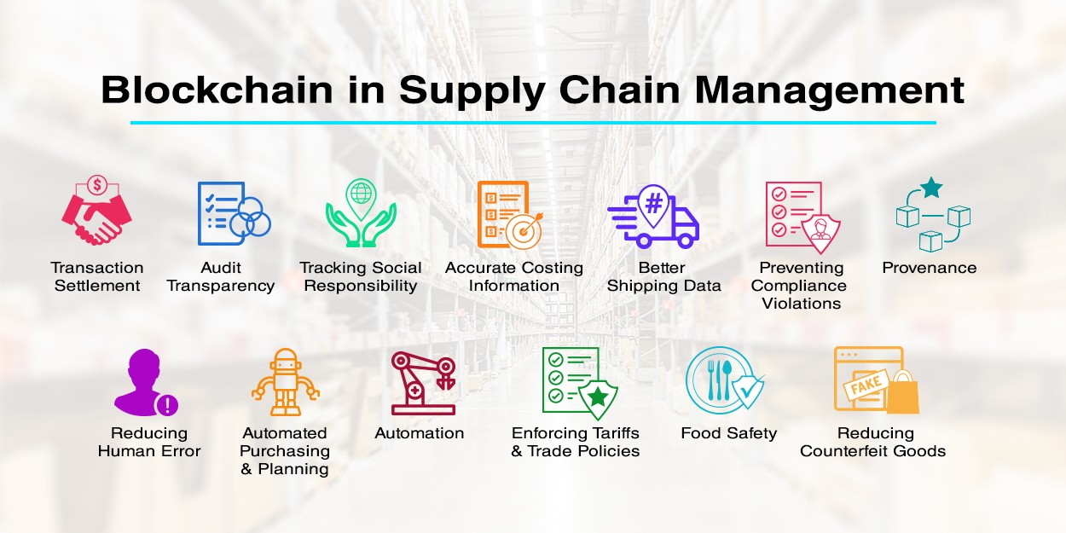

Fig.1 Blockchain in Supply Chain Management

**3.2 Smart Contracts in Supply Chain Management (SCM): Role of smart contracts in enhancing transparency and accountability of supply chain**

3.2.1 What are smart contracts and how do they function in the context of supply chain management?

Smart contracts are self-executing digital contracts that can revolutionize supply chain management. They define the agreement and conditions between two or more parties, automating the supply chain management procedures, including inventory control, order fulfillment, and payment processing. Smart contracts can help increase transparency and efficiency in supply chain management, providing real-time visibility into the status of goods and payments. Smart contracts can also optimize processes and reduce the potential for errors and disputes in supply chain management. Furthermore, supply chain management can use smart contracts to manage configuration and create a key management system for IoT devices. These contracts also make it easier to manage and control IoT systems by controlling user authentication, data sharing, and access control between devices. To maintain the predetermined standard of service and product quality in logistics supply chains, smart contracts automate the self-execution and self-enforcement of transactions between internal and external supply chain participants. The potential benefits of smart contracts in supply chain management are undeniable, including increased efficiency, reduced costs, improved customer satisfaction, and seamless collaborative visibility. However there are still issues with scalability and interaction with current systems, as smart contracts require careful negotiation and agreement among stakeholders in logistics supply chains. Nevertheless, smart contracts are being adopted in the field of supply chain management, with start-ups emerging with bespoke solutions that can drive efficiency and automation in supply chain management. Supply chain management will comprehensively use smart contracts, implementing them gradually from individual business operations to frameworks tailored to the needs of the industry. Smart contracts powered by blockchain technology are considered the future of automated agreements in supply chain management.

3.2.2 How do smart contracts enhance transparency in supply chain operations?

Smart contracts provide a range of benefits in supply chain operations, and one of the most significant ways is through enhancing transparency. Smart contracts enable real-time monitoring and verification of goods as they are delivered from one location to another, ensuring the authenticity of products in industries like food and pharmaceuticals. The use of blockchain technology's transparency aids in creating a tamper-proof record of each and every exchange and occurrence in the supply chain, providing an immutable and transparent record of all interactions, which is open to inspection by all parties involved. Collaborative visibility through smart contracts makes it easier to identify the source of any discrepancies, enabling stakeholders to resolve disputes quickly. Smart contracts also allow stakeholders to track products and raw materials during transit, enhancing transparency in supply chain operations. Additionally, smart contracts deployed on a blockchain enable decentralized tracking of containers and individual goods, providing traceability of products in the food supply chain to their provenance. Blockchain's intrinsic transparency generates a wealth of data that can be analyzed and questioned to provide advanced predictive analytics. Smart contracts also provide accurate information about the status and location of goods, allowing for a proactive approach to supply chain operations. Smart contracts and blockchain technology can also document the conduct of operations based on regulatory and governing body rules, enhancing overall supply chain visibility. Furthermore, smart contracts can automate supply chain operations, requiring no day-to-day management, reducing the need for intermediaries, and enhancing transparency in supply chain operations. Overall, the use of smart contracts in supply chain operations has the potential to revolutionize transparency in the industry.

3.3.3 In what ways do smart contracts increase accountability in supply chain transactions?

The supply chain sector will turn upside down thanks to smart contracts by increasing accountability and transparency in transactions. Smart contracts are created in computer code and distributed on the blockchain, where they will self-execute as digital agreements between transacting parties[19] according to the embedded rules that define the agreement and conditions between two or more parties. By enabling self-enforcement of transactions in supply chains, smart contracts can automate relationship management and offer a flexible solution for the parties involved in a transaction. Additionally, smart contracts can assess the status of a transaction and verify compliance with pre-agreed-upon rules, thus increasing accountability in the supply chain industry. Stakeholders in the logistics supply chain can also assist with decentralized tracking through the use of smart contracts implemented on a blockchain, It makes it easier to identify risks associated with vulnerabilities found in intricate supply networks early on. Furthermore, a smart contract can include functions for ordering items, canceling orders, updating item statuses, and retrieving status information, which all assist in increasing accountability and transparency in supply chain transactions. Thus, by leveraging blockchain-powered smart contracting, the supply chain industry can enhance overall visibility and ensure the authenticity of products in industries like food and pharmaceuticals.

**3.3 Implementation:**

Blockchains can be implemented leveraging open-source platforms such as Hyperledger Fabric, BigchainDb, and Multichain. However, for organizations seeking to deploy an internal blockchain solution, Ethereum or Python are viable options. In the development of our blockchain-centric logistics monitoring system, with a foundation deeply entrenched in the pharmaceutical domain, we chose to employ the Ethereum platform. Our localized blockchain development setup utilizes Ganache and Truffle, providing a conducive environment for the implementation of smart contracts. The seamless integration between our logistics monitoring system and the Ethereum blockchain is facilitated through the utilization of web3.js, a JavaScript library.

3.3.1 Need of Blockchain in Pharmaceutical Industry:

The World Health Organisation has underlined the tremendous issues that the pharmaceutical industry faces, with the global trade in counterfeit medications reaching an alarming estimate of up to $200 billion yearly. Surprisingly, internet channels are used to transact in half of these fake medications. Usually, the source of counterfeiting is contracted manufacturers or distributors that either inject counterfeit pharmaceuticals into the supply chain as seemingly authentic units or divert real drugs for resale. There is a technology gap in the market since existing solutions, such as electronic drug pedigree systems, struggle with traceability concerns because they rely on bilateral information transfers and isolated data sources. The Answer: Making Use of Blockchain and Smart Contract Technology acknowledging the pressing necessity for an all-encompassing resolution, we suggest incorporating blockchain systems to retain data and implement regulations across the pharmaceutical supply chain. With functions like these, smart contracts—which are optimized for effective data storage—can take on a more straightforward structure.[20]

3.3.2 Pharmaceutical supply chain smart contract pseudocode:

// Smart Contract Pseudocode

// Define Smart Contract

contract SupplyChain {

// State Variables

address public Owner;

uint256 public medicineCtr;

uint256 public rmsCtr;

uint256 public manCtr;

uint256 public disCtr;

uint256 public retCtr;

enum STAGE { Init, RawMaterialSupply, Manufacture, Distribution, Retail, Sold }

// Struct to store information about a medicine

struct Medicine {

uint256 id;

string name;

string description;

uint256 RMSid;

uint256 MANid;

uint256 DISid;

uint256 RETid;

STAGE stage;

}

// Mapping to store all medicines

mapping(uint256 => Medicine) public MedicineStock;

// Structs to store information about participants

struct RawMaterialSupplier { ... }

struct Manufacturer { ... }

struct Distributor { ... }

struct Retailer { ... }

mapping(uint256 => RawMaterialSupplier) public RMS;

mapping(uint256 => Manufacturer) public MAN;

mapping(uint256 => Distributor) public DIS;

mapping(uint256 => Retailer) public RET;

// Modifiers and Functions to add participants, supply chain stages, and transitions

modifier onlyByOwner() { ... }

function addRMS(...) public onlyByOwner() { ... }

function addManufacturer(...) public onlyByOwner() { ... }

function addDistributor(...) public onlyByOwner() { ... }

function addRetailer(...) public onlyByOwner() { ... }

function RMSsupply(...) public { ... }

function Manufacturing(...) public { ... }

function Distribute(...) public { ... }

function Retail(...) public { ... }

function sold(...) public { ... }

function addMedicine(...) public onlyByOwner() { ... }

// Function to show the stage of a medicine

function showStage(...) public view returns (string memory) { ... }

}

Smart Contract- This is an Ethereum-based self-executing contract named SupplyChain.sol with the extension “.sol”, it creates a decentralized and temper-proof leader.

Stakeholders- The stakeholders in the Pharmaceutical supply chain process are:

1. Owner: The owner is the person who deployed the smart contract and has the authority to authorize roles. The owner can add a block in the chain and monitor every transaction.

Every stakeholder below has the same attributes:

Address: address (Ethereum blockchain address)

ID: uint256 (unsigned integer)

Name: string (text)

Place: string (text)

1. Raw Material Supplier: They provide raw materials for medicine production
2. Manufacturer: produces medicine following WHO guidelines
3. Distributer: Distribute medicine to retailers
4. Retailer: Sells medicines to end consumers

The flow of supply chain: The process of ordering medicines begins with the Owner initiating the process, whereby medicines enter the "Init" stage. Subsequently, Raw Material Suppliers (RMS) provide the necessary raw materials, prompting medicines to progress to the "Raw Material Supply" stage. Following this, Manufacturers (MAN) undertake the production of medicines, advancing them to the "Manufacture" stage. Once manufactured, medicines proceed to the "Distribution" stage facilitated by Distributors (DIS), who ensure the efficient distribution of medicines. Subsequently, Retailers (RET) take charge of selling medicines to consumers, thus transitioning them to the "Retail" stage. Finally, when medicines are sold to consumers, Retailers mark them as "sold," signaling the transition to the "Sold" stage. This sequential process ensures the systematic flow of medicines from procurement to consumer distribution, ensuring effective supply chain management in the pharmaceutical industry.

Mapping: A mapping in the context of our smart contract acts as a dynamic database that associates unique identifiers with specific information about stakeholders. For example, we use mappings to link the Ethereum addresses of Raw Material Suppliers (RMS), Manufacturers (MAN), Distributors (DIS), and Retailers (RET) with their corresponding attributes, such as names and locations. Mapping enhances system efficiency by providing quick access to critical data points. At the time of a transaction, information is retrieved and updated seamlessly.

Mapping example: Mapping(uint256 => Medicine) public MedicineStock; is used to store information about medicines on the blockchain. ‘MedicineStock’ mapping works on key-value pairs. Unit256 is the key type for the unique identification of a medicine. Medicine is a struct that stores various details about a medicine. If the owner wants to retrieve information about a specific medicine, Let's say with ID ‘145’, the owner will use ‘MedicineStock[145]. It will return the associated ‘medicine’ struct with details about that medicine, making direct access to the information very fast.

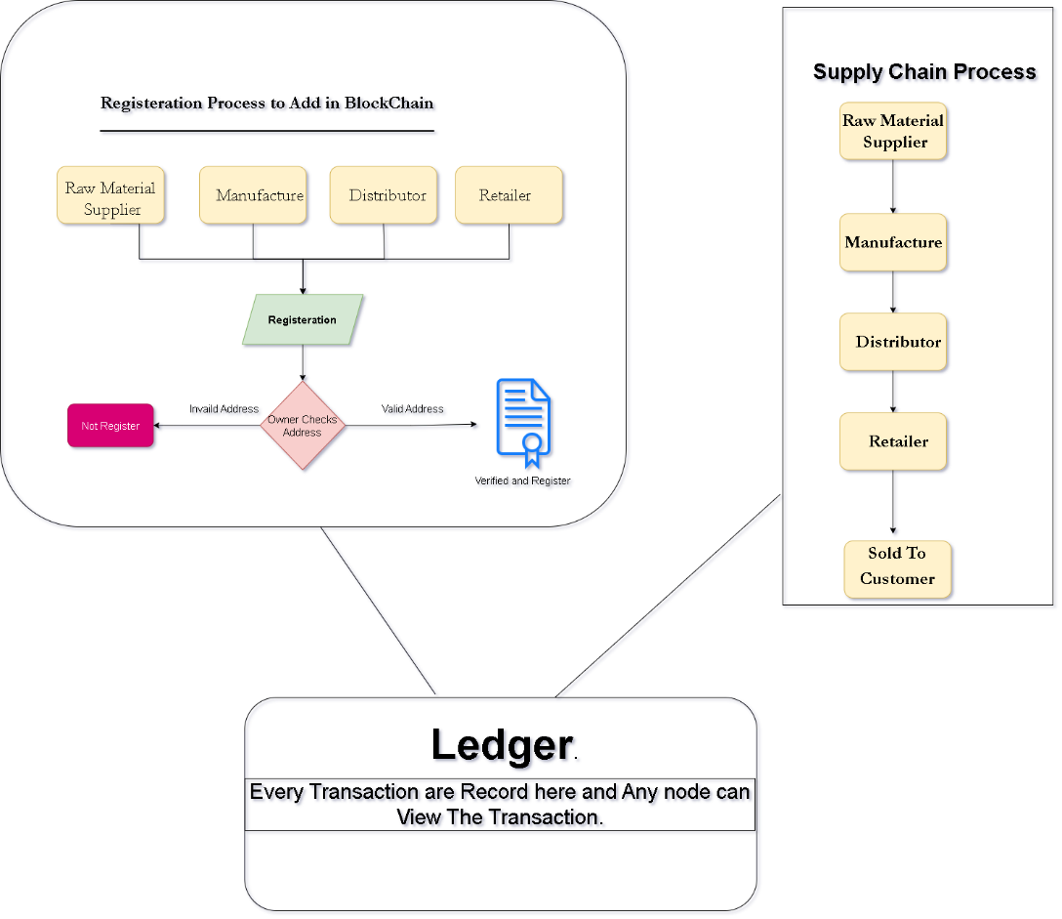

Fig 2. Pharmaceutical supply chain

**4. Result:**

The research findings explain the technology of blockchain applied in the field of supply-chain. Supply chain management can be revolutionized by using a decentralised platform. This paper addresses the present challenges in the monitoring of goods from the manufacturer to the end product customer, particularly focusing on traceability and transparency. The timely sharing and tracking of real-time product details across the supply chain ensure a smooth transportation process, facilitating the seamless movement of goods from producers to consumers.

Blockchain offers inherent benefits such as decentralization, transparency, and smart contract automation, addressing longstanding challenges within the industry. Notably, case studies like Walmart's successful implementation of a blockchain-based solution for tracking pork products from China emphasises benefits of blockchain in enhancing transparency and traceability throughout the supply chain.

The study also shows various applications of the practical world across various market sectors including food, pharmaceuticals, container shipping, and customs operations. projects by companies like IBM, De Beers, and others demonstrate how blockchain is being utilized to improve efficiency and transparency in logistics monitoring. These examples provide real-world evidence of blockchain's effectiveness in addressing specific challenges within supply chain management.

The tamper-proof record of all transactions enables stakeholders to verify the authenticity of products and track their location, enhancing trust and accountability. Despite the positive outlook of the decentralised ledger, the technology acknowledges various challenges of scalability, integration with current systems. By overcoming these hurdles, the blockchain holds a high potential to revolutionize the supply chain industry.

In conclusion, the research proposes a comprehensive framework to guide future research in blockchain-enabled supply chain management. By addressing current gaps in the literature and identifying areas for improvement, the research aims to drive innovation and progress in the field. The proposed framework lays the foundation for further exploration and implementation of blockchain technology in supply chain management, ultimately leading to enhanced efficiency, transparency, and sustainability across industries.

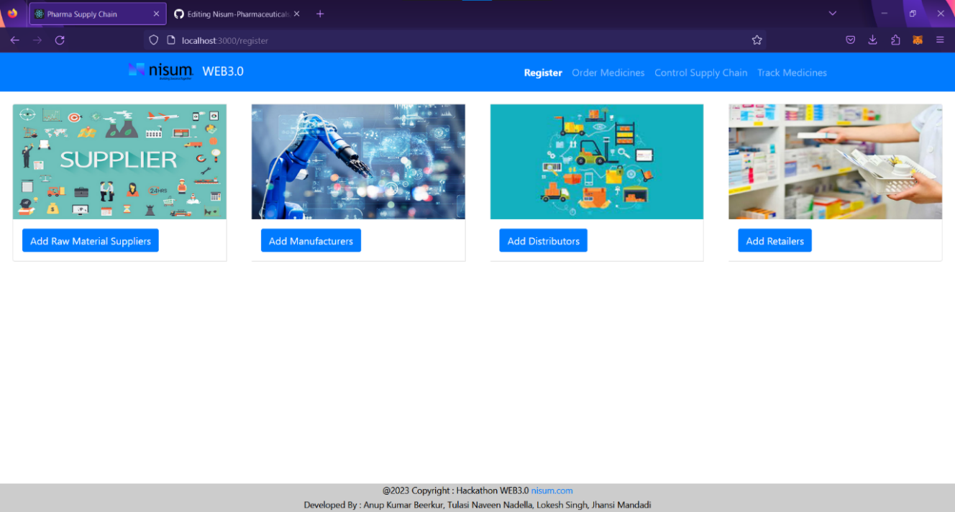

Fig 3. Supply-Chain Role Allocation

**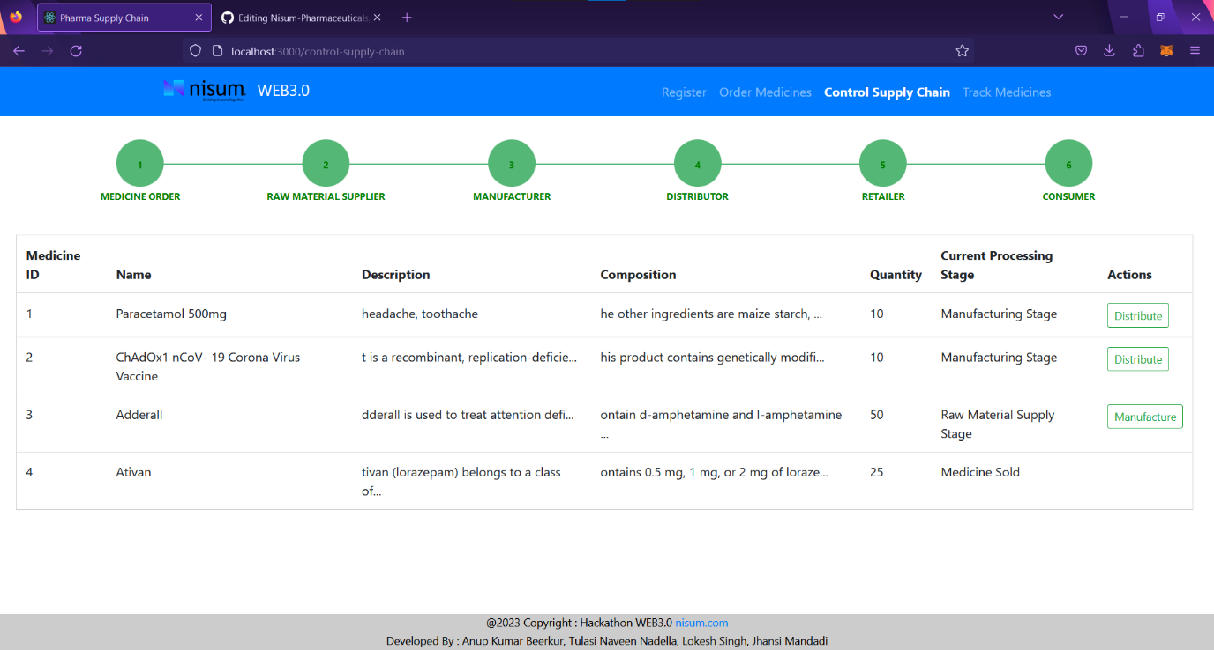**

Fig 4. Supply-Chain Control

**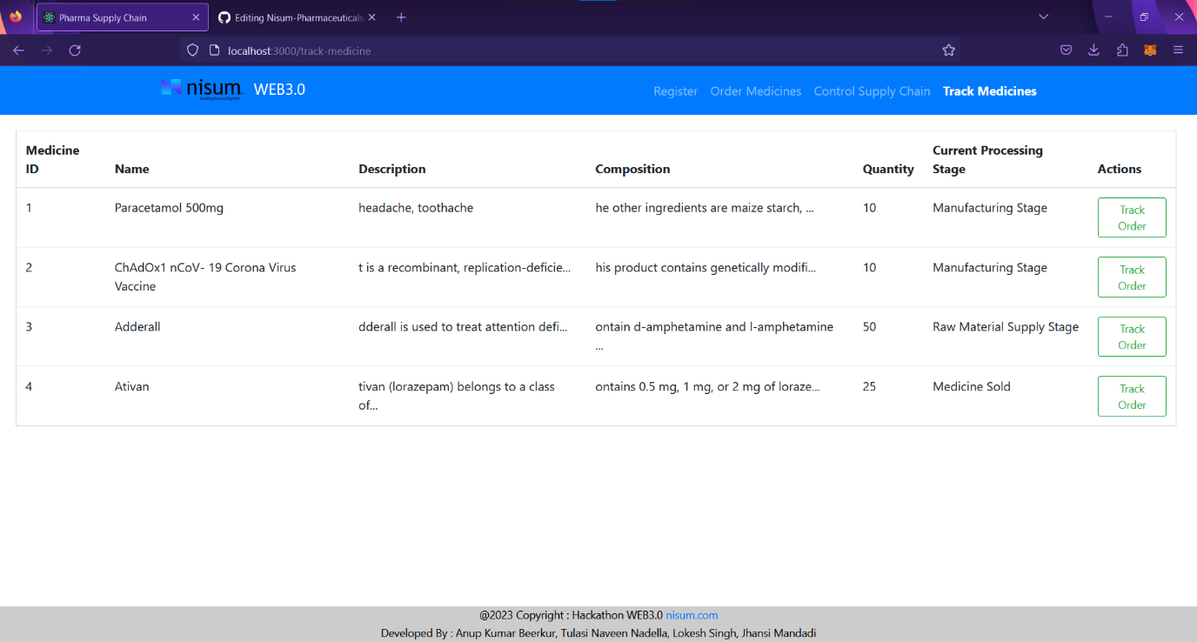**

Fig 5. Medicine Tracking page

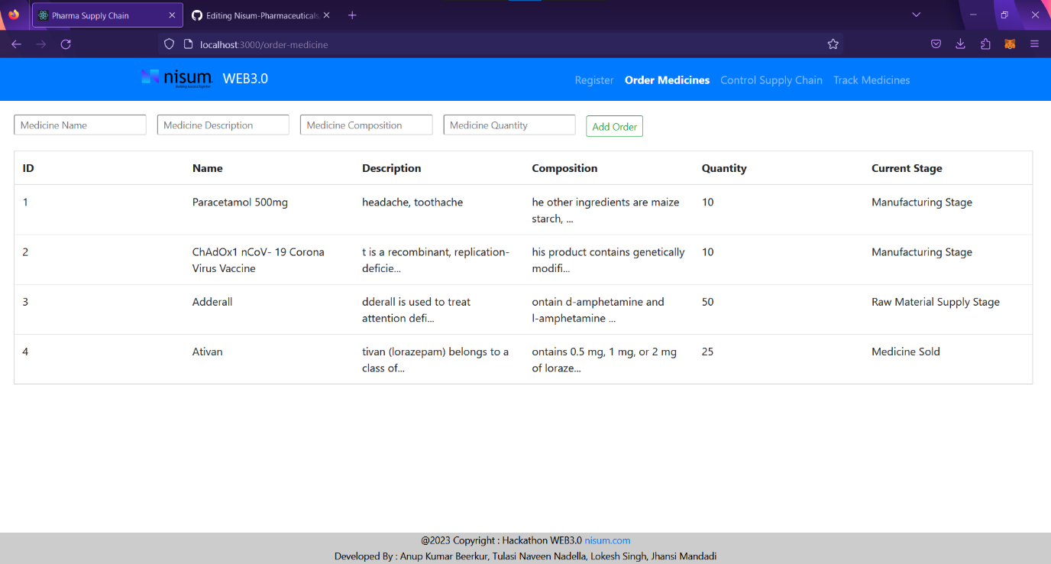

Fig 6. Order Medicine page

**5. Conclusion:**

According to the wide literature analysis, the integration of supply chain management (SCM) with blockchain technology shows enormous promise for transforming different elements of supply chain operations. Traceability, transparency, decentralization, visibility, smart contracts, accountability, immutability, and cybersecurity are some of the features provided by blockchain technology that may dramatically improve the efficiency and efficacy of supply chain systems. Despite the promised benefits, it is vital to recognize that blockchain technology is still in its early phases, with significant hurdles and impediments that must be overcome for its deployment. Scalability, regulatory concerns, a lack of standards, technological knowledge, and supply chain partner compatibility are among the hurdles. Nonetheless, blockchain technology's capacity to provide transparency, authenticity, and dependability to supply chain operations cannot be underestimated. It can deal with concerns like food safety, fraud prevention, traceability, and supply chain sustainability. Supply chain stakeholders may improve operational efficiency, increase participant confidence, manage risks, and meet regulatory obligations more effectively by adopting blockchain technology.   
  
Moving forward, both researchers and practitioners must prioritize joint efforts to overcome hurdles and maximize the benefits of blockchain integration in SCM. This includes deepening awareness of blockchain technology, investigating its possible uses in various industries, building regulatory frameworks, encouraging collaboration among supply chain partners, and investing in education and training efforts. Finally, integrating supply chain management with blockchain technology provides tremendous potential to improve supply chain resilience, transparency, and sustainability. While there are problems, the potential advantages exceed the drawbacks, and collaborative efforts are necessary to fully realize the promise of blockchain technology in supply chain management. Blockchain technology's incorporation into supply chain management provides a tremendous possibility to change existing businesses. Blockchain, with its fundamental qualities of decentralization, permanence, anonymity, and auditability, has the potential to transform several elements of supply chain operations. Through rigorous simulation design and analysis, it becomes clear that implementing blockchain technology may considerably enhance the supply chain. The simulation findings show that data may be successfully stored, organized, and connected, as indicated by the production of hashes for each block, assuring data integrity and traceability. A comparison of supply networks without and with blockchain demonstrates blockchain technology's viability in eliminating data risks in the supply chain. Despite hurdles such as cost concerns, organizations with a solid foundation in the industry are more likely to overcome these obstacles. There are several areas for future study in blockchain and supply chain management. Addressing concerns like security, privacy, scalability, energy consumption, regulatory compliance, and interaction with current systems will be critical in expanding the practical uses of blockchain technology. Furthermore, encouraging the use of blockchain-based supply chain cooperation, improving privacy protection mechanisms, clarifying related legislation and regulations, and developing industry standards are critical steps toward achieving blockchain's full potential in SCM. Innovative techniques, such as combining blockchain and the Internet of Things (IoT), hold promise for addressing long-standing supply chain management difficulties. These techniques improve supply chain security, transparency, and trust by making use of decentralized tracking, tracing, and smart contract capabilities. Furthermore, they help to reduce mistakes, fraud, delays, and expenses while increasing efficiency, accuracy, and sustainability. To summarize, incorporating blockchain technology into supply chain management has enormous promise for streamlining operations, assuring transparency, and building trust across sectors. While hurdles remain, continuing study, experimentation, and cooperation will lead the path to fulfilling blockchain's full promise in transforming supply chain management techniques.

The use of blockchain technology in supply chain management, notably in the pharmaceutical and healthcare industries, presents a possible solution to issues such as counterfeit pharmaceuticals, security breaches, and inefficiencies. Organizations may create transparent and traceable supply chain monitoring systems by exploiting blockchain's decentralized and tamper-proof features, as well as smart contracts. The suggested blockchain-based solutions show cost savings, increased security, and automation of record-keeping activities. Stakeholders may have access to verifiable and immutable event logs using cryptographic foundations and smart contract features, assuring transaction data integrity, availability, and non-repudiation. Furthermore, the combination of blockchain with IoT improves supply chain management by allowing for decentralized tracking and tracing of medical supplies, lowering mistakes, fraud, delays, and prices. The employment of the model improves inventory management while minimizing damage during transportation, thereby increasing efficiency and sustainability. Overall, blockchain technology provides a strong foundation for addressing the difficulties of contemporary supply chains by ensuring end-to-end transparency, security, and trust. Continued research and testing will help to develop and confirm these solutions, opening the door for wider adoption and transformation of supply chain operations.   
  
  
  
**References:**

*1. Nakamoto, S. (2008). "Bitcoin: A Peer-to-Peer Electronic Cash System." Retrieved from* [*https://bitcoin.org/bitcoin.pdf*](https://bitcoin.org/bitcoin.pdf) *.*

*2. Wang, K., & Zuo, L. (2020). "Blockchain-Enabled Supply Chain: Design Models and Applications." IEEE Transactions on Engineering Management, 67(4), 1317-1329. doi:10.1109/TEM.2019.2934007*

*3.* *Allison, I., “IBM enlists Walmart, Nestlé, Unilever, Dole for food safety blockchain,” International Business Times, August 24, 2017. www.ibtimes.com/ibm-enlists-walmart-nestleunilever-dole-food-safety-blockchain-2582490.*

*4. Abeyratne, S. and Monfared, R. (2016) ‘Blockchain Ready Manufacturing Supply Chain Using Distributed Ledger’, International Journal of Research in Engineering and Technology, 05(09), pp. 1–10. doi: 10.15623/ijret.2016.0509001.*

*5. 7 Major Blockchain Technology Developments in Maritime Industry in 2018 (2019). Availableat:https://www.marineinsight.com/know-more/7-major-blockchain-technologydevelopments-in-maritime-industry-in-2018/ (Accessed: 5 July 2019).*

*6. MediLedger Pilot Project participants include: AmerisourceBergen, Amgen, Cardinal Health, Center for Supply Chain Studies, Dermira, Eli Lilly, Endo, FedEx, FFF Enterprises, Chronicled, Genentech, Gilead, GS1, Glaxo Smith-Kline, Hikma, Inmar, Maxor, McKesson, Novartis (Sandoz), Novo Nordisk, Pfizer, Sanofi, Vax-serve, Walgreens, and Walmart.*

*7. De Beers Group. (2018). https://www.debeersgroup.com/the-group/our-history. Retrieved on 16th November.*

*8. Israeli Diamond Industry. (2018). The Industry’s Benchmark: Rapaport Price list. https://en.israelidiamond.co.il/wikidiamond/diamond-industry-history/benchmarkrapaport-price-list, Last accessed 12th December.*

*9. Yli-Huumo, J.; Ko, D.; Choi, S.-J.; Park, S.; Smolander, K. Where Is Current Research on Blockchain Technology?—A Systematic Review. PLoS ONE****2016****, 11, e0163477. [*[***Google Scholar***](https://scholar.google.com/scholar_lookup?title=Where+Is+Current+Research+on+Blockchain+Technology?%E2%80%94A+Systematic+Review&author=Yli-Huumo,+J.&author=Ko,+D.&author=Choi,+S.-J.&author=Park,+S.&author=Smolander,+K.&publication_year=2016&journal=PLoS+ONE&volume=11&pages=e0163477&doi=10.1371/journal.pone.0163477&pmid=27695049)*] [****[CrossRef](https://doi.org/10.1371/journal.pone.0163477" \t "_blank)****] [*[***PubMed***](http://www.ncbi.nlm.nih.gov/pubmed/27695049)*]*

*10. Christopher Fabian, “Un-chained: experiments and learnings in crypto at UNICEF”, Innovations: Technology, Governance, Globalization, vol. 12, No. 1-2 (Summer-Fall 2018).*

*11. Agrawal, P., & Narain, R. (2021). Analysis of enablers for the digitalization of supply chain using an interpretive structural modelling approach. International Journal of Productivity and Performance Management.*[*https://doi.org/10.1108/ijppm-09-2020-0481*](https://doi.org/10.1108/ijppm-09-2020-0481)*.*

*12.https://newsroom.accenture.com/news/2018/dhl-and-accenture-unlock-the-power-of-blockchain-in-logistics*

*13.https://www.dhl.com/content/dam/dhl/global/core/documents/pdf/glo-core-blockchain-trend-report.pdf*

*14. AJOT (2018), Maritime Blockchain Labs Announces New Consortium to Improve Crew Management and Streamline Related Documentation, Maritime News, Retrieved from: https://www.ajot.com/news/maritime-blockchain-labs-announces-new-consortium-to -improve-crew-management-and-streamline-related-documentation.*

*15.* Gunasekaran, A.; Sarkis, J. Research and applications in e-commerce and third-party logistics management. *Int. J. Prod. Econ.* 2008, *113*, 123–126. [[Google Scholar](https://scholar.google.com/scholar_lookup?title=Research+and+applications+in+e-commerce+and+third-party+logistics+management&author=Gunasekaran,+A.&author=Sarkis,+J.&publication_year=2008&journal=Int.+J.+Prod.+Econ.&volume=113&pages=123%E2%80%93126&doi=10.1016/j.ijpe.2007.07.002)] [[CrossRef](https://doi.org/10.1016/j.ijpe.2007.07.002" \t "_blank)].

*16.* Mardani, A.; Kannan, D.; Hooker, R.E.; Ozkul, S.; Alrasheedi, M.; Tirkolaee, E.B. Evaluation of green and sustainable supply chain management using structural equation modelling: A systematic review of the state of the art literature and recommendations for future research. *J. Clean. Prod.* 2020, *249*, 119383. [[Google Scholar](https://scholar.google.com/scholar_lookup?title=Evaluation+of+green+and+sustainable+supply+chain+management+using+structural+equation+modelling:+A+systematic+review+of+the+state+of+the+art+literature+and+recommendations+for+future+research&author=Mardani,+A.&author=Kannan,+D.&author=Hooker,+R.E.&author=Ozkul,+S.&author=Alrasheedi,+M.&author=Tirkolaee,+E.B.&publication_year=2020&journal=J.+Clean.+Prod.&volume=249&pages=119383&doi=10.1016/j.jclepro.2019.119383)] [[CrossRef](https://doi.org/10.1016/j.jclepro.2019.119383" \t "_blank)].

*17. Zakari, N., Al-Razgan, M., Alsaadi, A., Alshareef, H., Alashaikh, L., Alharbi, M., Alomar, R., & Alotaibi, S. (2022). Blockchain technology in the pharmaceutical industry: A systematic review. PeerJ Computer Science, 8. https://doi.org/10.7717/peerj-cs.840.*

*18. Kamath, Reshma. 2018. “Food Traceability on Blockchain: Walmart’s Pork and Mango Pilots with IBM.” The Journal of The British Blockchain Association 1 (1).*[*https://doi.org/10.31585/jbba-1-1-(10)2018*](https://doi.org/10.31585/jbba-1-1-(10)2018).

*19.* *Priyanka Kumar, G. A. Dhanush, D. Srivatsa, A. Nithin, S. Sahisnu. "Chapter 43 A Buyer and Seller’s Protocol via Utilization of Smart Contracts Using Blockchain Technology" , Springer Science and Business Media LLC, 2019*

*20. Lory Kehoe, Niamh O’Connell, Danielle Andrzejewski, Kai Gindner, Darshini Dalal https://www2.deloitte.com/tr/en/pages/technology/articles/when-two-chains-combine.html “When two chains combine|Supply Chain Meets Blockchain*

*M. Pantina. (1999) MS Windows NT 2021 third quarter supply chain risk*

*trends analysis | cargonet. [Online]. Available: https://www.cargonet.com/*

*news-and-events/cargonet- in-the-media/2021-q3-theft- trends*

*[4] P. Sangeerth and K. Lakshmy, “Blockchain based smart contracts in*

*automation of shipping ports,” in 2021 6th International Confer*

*M. Pantina. (1999) MS Windows NT 2021 third quarter supply chain risk*

*trends analysis | cargonet. [Online]. Available: https://www.cargonet.com/*

*news-and-events/cargonet- in-the-media/2021-q3-theft- trends*

*[4] P. Sangeerth and K. Lakshmy, “Blockchain based smart contracts in*

*automation of shipping ports,” in 2021 6th International Confer*

*M. Pantina. (1999) MS Windows NT 2021 third quarter supply chain risk*

*trends analysis | cargonet. [Online]. Available: https://www.cargonet.com/*

*news-and-events/cargonet- in-the-media/2021-q3-theft- trends*

*[4] P. Sangeerth and K. Lakshmy, “Blockchain based smart contracts in*

*automation of shipping ports,” in 2021 6th International Confer*

In 2008, Satoshi Nakamoto published an article named ’ Bitcoin: a peer-to-peer electronic cash system’, proposing a brand-new concept, bitcoin. The source code of the Bitcoin system was published two months later in 2009, making it possible for everyone to use it. In addition, the original fifty bitcoins in the world have been created by a new block named Genesis Block. he revolution of SCM relies on reliable and efﬁcient

data management, in which the data collected from supply

chains are supposed to be stored, integrated, and retrieved

with reliability and high efﬁciency. Facing the aforementioned

issues, people are heading towards the application of

blockchain technology on SCM. Blockchain, which originated from

Bitcoin, is an implementation of an append-only ledger. It

stores fully traceable and immutable records, which can be

transformed from the data along with the supply chain, e.g.,

product and sales information. As such, blockchain enables

the authenticity of the digitalized data in the supply chain